**AIM:**

To study apriori algorithm in weka

**THEORY:**

The Apriori algorithm was proposed by Agrawal and Srikant in 1994. Apriori is designed to operate on databases containing transactions (for example, collections of items bought by customers, or details of a website frequentation).

The Apriori Algorithm is an influential algorithm for mining frequent itemsets for boolean association rules. • Apriori uses a "bottom up" approach, where frequent subsets are extended one item at a time (a step known as candidate generation, and groups of candidates are tested against the data

**USING FULL TRAINING SET:**

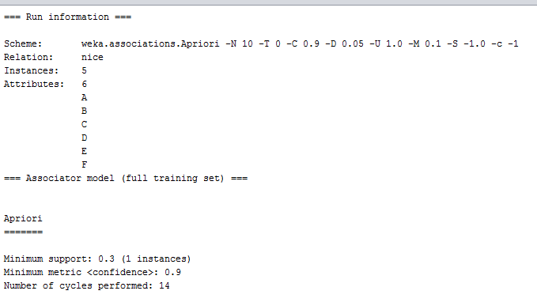

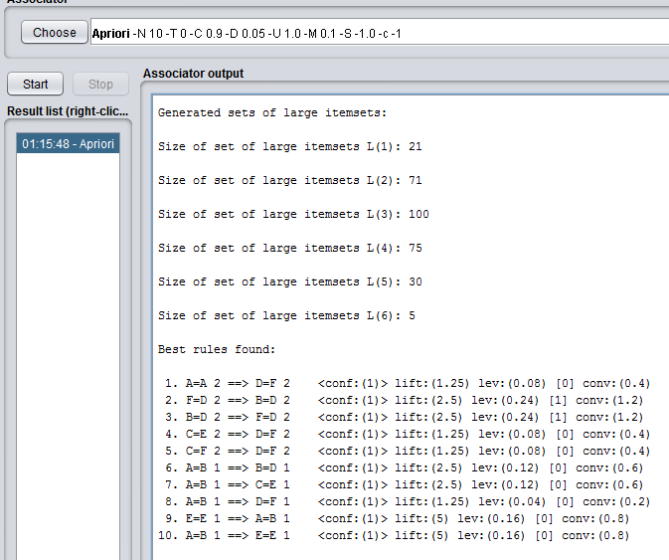

**CONCLUSION**:  
To investigate and discuss the application and improvement about Apriori algorithm of association rules mining (ARM).